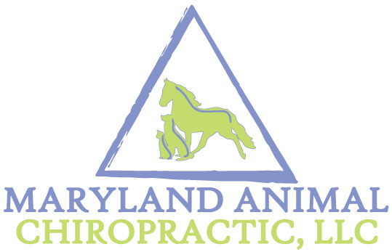
KEEPING YOUR PET ALIGNED FROM HEAD TO TAIL 443-201-1508 info@marylandanimalchiropractic.com

Dr. Jean Thompson founded Maryland Animal Chiropractic, LLC (MAC) in 2009 due to her passion for all animals and the demand for serving animal patients suffering from neck and back pain, arthritis, sprains and other ailments. Dr. Thompson is a Doctor of Chiropractic, earning her degree from Logan College of Chiropractic in Missouri. She specializes in animals, working mostly with equine, canine and feline species. Dr. Thompson is an international instructor for the elite animal chiropractic school, Options for Animals College of Animal Chiropractic, where she completed her coursework and was awarded certification by the International Veterinary Chiropractic Association (IVCA).
Animal Chiropractic is a field of animal health care that focuses on the preservation and health of the neuro-musculo-skeletal system. Why? Nerves control everything that happens in animals. Anything adversely affecting the nervous system will have detrimental effects that will resonate throughout the entire body. The command centers of the nervous system are the brain and spinal cord which are protected by the spine. The spine is a complex framework of bones (vertebra), ligaments, muscles and nerves. If the movement and biomechanics of the vertebra become dysfunctional, they can interfere with the performance of the nerves that are branching off of the spinal cord and going to all of the muscles and organs. As this occurs, animals can lose normal mobility; resulting in stiffness, tension, pain and even organ dysfunction. Additionally, when normal movement is affected, and left unattended, it will ultimately impact an animal’s entire wellbeing and quality of life.
The nervous system also coordinates the body’s ability to heal and regulate itself. Trauma, overuse or underuse may cause the vertebra of the spine to become fixed and the surrounding muscles and ligaments may become compromised and inflamed. Nerves could become trapped in these damaged tissues or in the passages they use to exit the spine and their signals become unable to adequately reach their destinations. This causes these impaired structures to lose their ability to heal. The goal of an animal chiropractor is to restore function and mobility to the compromised vertebra in an effort to re-establish neurologic transmissions. This allows the body to perform at its optimum potential.
This is the beginning of a more modern, comprehensive approach to an animal’s healthcare. It is an effective and valuable means of restoring and maintaining their strength, vigor and well-being. By exploring and treating the root causes of the animal’s aches, pains and illnesses, it will ensure maximum improvement, top performance and an exceptional quality of life.
Pet owners and veterinarians turn to chiropractic for a number of different reasons:

- Hip dysplasia
- Disc disease
- Acute or chronic injury
- Iliopsoas Strain
- Altered sitting “puppy sitting”
- Difficulty or reluctance going up or down stairs
- Gait abnormalities / Lameness
- Weakness in the hind end

- Neurological disease
- Pain in the back or neck
- Constant licking or chewing paw

*Chiropractic care does not replace regular veterinary care; rather it is an integrative method that when used in conjunction with good traditional veterinary care, will provide years of happy and healthy living. A signed veterinary referral form is required by Maryland Animal Chiropractic, LLC prior to providing chiropractic care to all animal patients.
WHERE TO FIND US:
Small Animals (Dogs, Cats, etc.): Our doctors see small animals at the following clinics/locations:

- Paradise Animal Hospital
6350 Frederick Road
Catonsville, MD 21228
410-740-4224
(THURSDAY afternoons)

- VCA Columbia @ Hickory Ridge
10788 Hickory Ridge Road
Columbia, MD 21044
410-730-2122
(THURSDAY mornings)

Equine: MAC services barns throughout the state of Maryland assisting in boosting performance, injury recovery, arthritis and stiffness, abnormal gait, lameness, and many other issues.

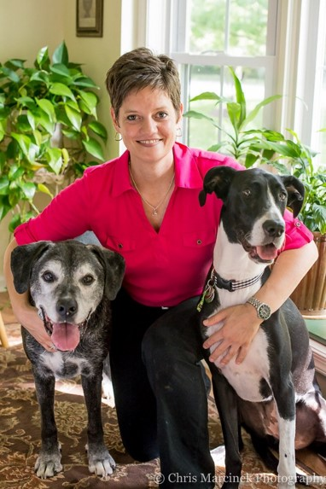

(Dr. Thompson with her dogs, Goose, and Beckett)

